|  |  |  |  |  |
| --- | --- | --- | --- | --- |
| **C:\Users\Arzu_ŞENTÜRK\Desktop\R2.jpgC:\Users\Arzu_ŞENTÜRK\Desktop\Untitled-2.jpgResearch Article** | **Test the Effect of Perceived Satisfaction, Motivation and Anxiety on Second Life Environment in Distance Learning Model: Structural Equation Modeling**[[1]](#footnote-1) | | | |
|  |  |  |  |  |
|  |  | **El-Nour Omar**[[2]](#footnote-2) -**Azhari Drewsh**[[3]](#footnote-3) -**Abdomalik Ahmed**[[4]](#footnote-4) | | |
|  |  |  |  |  |
|  |  | **Abstract:** | | |
| ***International Journal of Modern Education Studies***  June, 2018  Volume 2, No 1  Pages: 34-45  <http://www.ijonmes.net>  [dergipark.gov.tr/ijonmes](http://www.dergipark.gov.tr/ijonmes)  **Article Info:**   |  |  | | --- | --- | | Received | : 13.01.2018 | | Revision 1 | : 18.05.2018 | | Accepted | : 27.06.2018 | |  |  | | | *The main purpose of the present study is to predict the relationship between motivation , anxiety, perceived satisfaction and Second Life within asynchronous learning environment specifically in EFL course. Data of the present study were collected from undergraduate students - Sudan University of Technology and Science (SUST) in Sudan. The Questionnaire was conducted manually. Structural Equation Modelling (SEM) Version 16 and SPSS Version 11.5 were used. A hypothesized model was tested for model fit in the present study. The convergent validity and discriminant validity were conducted. The exogenous variables showed that Motivation was positively and significantly related to anxiety statistically level was 0.29 and Motivation was positively and significantly related to second life statistically level was 0.32 , anxiety positively and significantly related to Second Life statistically level was 0,25 whereas, perceived satisfaction was excluded in this study because did not satisfy statistical requirement. Therefore, the study was conducted in asynchronous learning environment, particularly in EFL course which is offered to undergraduate students at Deanship of Distance Education - Sudan University of Technology and Science (SUST) - Sudan.* | | |
| **Keywords:** | | Motivation, perceived satisfaction, anxiety, second life, asynchronous learning | | |
|  | |  | | |
|  | |  | | |
| **Citation:** | |  | | |
| Omar, E., Drewsh, A., & Ahmed, A. (2018). Test the effect of perceived satisfaction, motivation and anxiety on second life environment in distance learning model: Structural equation modeling. *International Journal of Modern Education Studies, 2*(1), 34-45. | | | | |

**INTRODUCTION**

Nowadays. the use of Virtual worlds for educational purposes increasing dramatically. The users in the second life enable to interact as an authentic world and communicate with each other through avatar. Furthermore, second life developed by Linden Lab in 2003 as free program. In fact, second life offers on line virtual houses either the participants reside or rent in them. Second life is environment designed by 3D animation that appear in a real life world. The role of participants can more freely and share ideas as well as real life and chat and send messages. Baleikanli (2012), postulates that second life a play ground people can augment their interaction via constructive play /work, equally, scientists and researchers examine and proof effectiveness of second life environment in teaching and learning. SL has provides various merits learners active constructors of knowledge who bring their own needs, strategies and skills, beside that they constructs a perfect context to meet all such learners needs. moreover, learning environment that provides opportunities for learners to collaborate, to discuss new information.

***Distance Education in the Sudan***

There is no doubt that the 21st century is the age of innovation of the World Wide Web (WWW). Instant Information and Communication Technologies (ICTs), which are used in many Fields of knowledge such as science, medicine and education, is no exception. It has been acknowledged that the Internet in educational arena has changed the role of the teachers from transmitter of information to the learners, as well as shifting the role of the learners from information and memorizing it to effective participants. Therefore, the internet has increased instructors engagement with students specifically in the online interaction course also it has enhanced self - directed learning among students. According to Rosenberg (2001), e-learning provides three benefits namely: Networks which facilitate instant update, storage, retrieval and sharing of information and it is delivered via computer using standard internet technology.. Azhari (2009) postulates that in the earlier of 1960s the national T.V had attempted to disseminate educational learning English language program throughout the capital city – Khartoum the program had functioned for a limit period approximately two years. Furthermore, during that time University of Khartoum endeavors to offer distance education program in 1963 for vocational discipline as well as technicians in order to improve their responds and motivation to the societal needs. In fact, in the earlier of 1990s Sudan took series steps toward distance education and established Open university of Sudan as well as some higher institutions which began to adopt the philosophy of distance education. Currently there are some strategies have been adopted to implement electronic learning across Sudanese universities.

***Anxiety***

Anxiety can be defined into three ways : State, trial ,situation – specific. The people experience moment in reaction to certain situation as an individual personality .Thus, anxiety is central motivation as potential factor ,Spielberger (1983)defines anxiety as subjective feeling of tension ,apprehension ,nervousness and worry associated with aroused of the auto – nomic nervous system .

***Motivation***

Motivation is the direct reason to cause, inspired system some sort of human behavior and people can be divided into three categories achievement , social and impression. Motivation is a word that can be used to label or identify the relationship between how someone performs and what is expected of him, and the degree to which environmental events affect his behavior as expected (Solane & Jackson, 1974, p.5). Motivation study deals with the processes that give behavior its energy and direction (Reeve, 1992, p.7). Reeve (1992) explained that motivation can be self-regulated or environmentally regulated. A motivational study needs to control both of these variables in order to be effective (p. 13).

***Perceived satisfaction***

Satisfaction has been addressed to be a very important component for the successful completion of the learning courses in different environments. Perceived satisfaction is known to be of great value in understanding students’ perceptions and evaluations , repeatedly showing itself to be an important indicator of future students' behavior.

***Problem statement***

English language in distance education program seems to be problematic specifically at Deanship of distance education - Sudan University of Technology and Science (SUST) due to lack of oral communication, a conducive environment and social interaction among the learners during consultations hours. Furthermore, learners may increase their English language oral communication by many means such as animation interactive environment and mitigate their anxiety towards oral communication. They will to increase their motivation. Moreover, there is a serious lack of research on the utilized Second Life as English Foreign Language learning environment (Aydin, 2013).

Second Life

Anxiety

Motivation

Perceived satisfaction

*Figure 1:* Conceptual framework adopted from Christopoulos, (Aydin, 2013).

***Research question***

The major research question of this study is as follows:

1. Is there statistically positive relationship between perceived satisfaction, anxiety and motivation in second life (SL) environment?

***Objective of the study***

1. To explore the relationship between perceived satisfaction, anxiety and motivation in second life (SL) environment.

***Hypotheses of the study***

The following hypotheses of the present study are:

H1: Student anxiety will be positively related to Second Life.

H2: Student motivation will be positively related to Second Life.

H3: Perseverance satisfaction will be positively related to Second Life.

H4: Student motivation will be positively related to Second Life via perseverance satisfaction.

H5: Student anxiety will be positively related to Second Life via perseverance satisfaction.

Past studies have been conducted on the relationship between perceived satisfaction and Second Life. They verified that ability to motivation, anxiety, and perceived satisfaction related to Second Life. Wehner, et al (2011) virtual worlds could be valuable resource to lower student anxiety and increase their motivation to learn a foreign language. Wang et al (2012) the study showed that the result showed that SL served appropriately both as a language learning and a motivation factor. The scholars Wang et al (2009) conducted a study and the result showed that the audience integrated SL into an EFL program. Balcikanli (2012) the result showed that SL served as a good bridge for cultural competence. SL contributes to authentic interaction with native language Petuson (2012) SL appeared to enhance discourse engagement and provides social interaction and language practice. Wang, et al (2012) the SL in EFL language program had a positive impact on students’ EFL learning. Li et al (2012), the result shows motivation has effects on the learning outcomes in second life, in addition, Kruk (2013) the result shows students have high level of motivation to learn English in second life and a lower level of anxiety. In summary, motivation and can be used in learning languages in order to increase lowers motivation and lower anxiety of languages fields.

**METHOD**

This study was used the quantitative survey research approach Rence (2004), a survey approach is appropriate technique to ask people about self-report, beliefs or behaviours and for statistical analysis the Structural Equation Modelling (SEM) with AMOS software were used in order to develop a model that reflects the relationships among the variables of the present study, namely: Perceived satisfaction, motivation and anxiety. The data of this study were collected through the questionnaires which were second life dimension was adapted from Christopoulos, A (2013), motivation anxiety and perceived satisfaction adapted from Yousef (2011).

***Research participant and data collection***

The data were collected via traditional questionnaire. In this study the respondents were selected by utilizing stratified technique random sampling. The Structural Equation Modelling (SEM) was used to address the objectives of the present study. Descriptive research method involves data in order to reflect the attitudes, opinions towards a specific social event, also investigates the relationships numerically.

|  |  |  |
| --- | --- | --- |
| Table 1  *Demographic information of the participants (N=331)* | | |
| **Variable** | **Scale** | **Frequencies (%)** |
| Gender | Male | 45.6 |
|  | Female | 54.4 |
| Age | 20 -24 years | 15.7 |
|  | 25- 29 years | 32.0 |
|  | 30 -34years | 29.0 |
|  | 35- 39 years | 11.2 |
|  | Over 40years | 12.1 |

***Instrumentation***

A questionnaire employing the 5-point Likert scale with 1 = Strongly Disagree) and 5 = Strongly Agree was used. The questionnaire comprised 51 items which measured four major constructs. The questionnaire was adapted from Christopoulos, A (2013) and Yousef M. (2011). A pilot study was conducted in 2015 at deanship of distance education Sudan University of Science and Technology (SUST) to establish the reliability of the questionnaire. The Cronbach alpha index obtained as α = 0.90 overall, with Motivation, Anxiety, and Second life reporting α = 0.90, α = 0.90, and α = 0.90 respectively. The questionnaire was attached to 331 respondents who interact in face to face program. To avoid the ambiguity of the items. The questionnaire was emerged fully fledge after many abortive test, in reality, every aspect of a survey has to be tried at beforehand to make sure that it works as intended (Oppenheim (1992, P.47 ).Some scholars agree that when a researcher conduct pilot test to assess internal consistency and they believed that the value of Cronbach Alpha is greater than 0.60 – 0.70 in exploratory studies, in other words, the range of Cronbach Alpha between 0.00 to 1.00 and close to 1.00 is perfect or is higher reliability, whereas, a score of Cronbach Alpha 0.90 is acceptable. Kline (2005), Gray (2004) Hair et al (2010).

***Data Analysis***

Structural Equation Modeling (SEM) was used in order to estimate the hypotheses. Version 16 of AMOS was employed, two ways were conducted firstly: Test measurement model via Confirmatory Factor Analysis (FCA) to obtain reliability and validity of the items in other words, to test the relationship between observed variables and latent variables. Secondly: Structural model employed to test the relationship among latent variables.

***Convergent validity***

The convergent validity (CV) of the questionnaires of present study was carried out based on Fornell and Larcker (1981), CV loading > 0.7, CR > 0.7 and AVE should be > 0.5. These requirements are presented in the table (2) as illustrated below.

|  |  |  |  |  |
| --- | --- | --- | --- | --- |
| Table 2  *Summary of discriminant validity for second life* | | | | |
| **Construct** | **1** | **2** | **3** | **4** |
| Second Life | 0.779 |  |  |  |
| SL2 | 1.784 |  |  |  |
| SL3 | 1.115 | 1.585 |  |  |
| SL4 | 0.943 | 1.011 | 1.462 |  |
| SL5 | 0.885 | 0.949 | 0.803 | 1.478 |

***Note:*** *Diagonals represents the average variance extracted, whereas the other matrix entries represent the square correlations.*

***Discriminant validity***

The discriminant validity of this model evaluated based on Fornell and Larcker (1981) criteria, square root of the (AVE) values were carried out for each dimension separately. In addition, Teo (2009) proposed that to assess discriminant validity for factor should compare the square roots of average variance extracted (AVE) to teach factor with connections between that construct and all other constructs.

|  |  |  |
| --- | --- | --- |
| Table 3  *Summary of discriminant validity for anxiety* | | |
| **Construct** | **1** | **2** |
| Anxiety | 0.732 |  |
| An2 | 1.564 |  |
| An3 | 0.718 | 1.413 |

***Note:*** *Diagonals represents the average variance extracted, whereas the other matrix entries represent the square correlations.*

|  |  |  |  |
| --- | --- | --- | --- |
| Table 4  *Summary of discriminant validity of motivation* | | | |
| **Construct** | **1** | **2** | **3** |
| Motivation | 0.707 |  |  |
| Mot1 | 1.788 |  |  |
| Mot 2 | 0.705 | 1.686 |  |
| Mot 3 | 1.453 | 1.453 | 1.453 |

***Note:*** *Diagonals represents the average variance extracted, whereas the other matrix entries represent the square correlations.*

|  |  |  |  |  |
| --- | --- | --- | --- | --- |
| Table 5  *Summary of discriminant validity for factors of anxiety, motivation and second life* | | | | |
| **Construct** | **Indicators** | **Factor Loading** | **CR** | **AVE** |
| Anxiety | An2 | 0.763 | 0.828 | 0.536 |
| An3 | 0.700 |  |  |
| Motivation | Mot1 | 0.700 | 0.742 | 0.500 |
| Mot 2 | 0.700 |  |  |
| Mot3 | 0.700 |  |  |
| Second Life | SL2 | 0.763 | 0.846 | 0.607 |
| SL3 | 0.868 |  |  |
| SL4 | 0.765 |  |  |
| SL5 | 0.714 |  |  |

**RESULTS**

The present study was used Analysis of Moment Structure (AMOS) version 16 to estimate model fit by using Maximum Likelihood (ML). According to Davy & Savla (2010), Byrne (2010), Hair, et al (2010) emphasized that to measure model fit indices through three types of models : Incremental model which includes these fit indices TLI > .90 close to 1, CFI and NFI > .90 AGFI close to zero, while absolute model measures separately and fit indices chi square value < 3, GFI zero to 1.0 and great value is accepted, RMSEA < 0.05 to 1.0 is acceptable fit .The structural model of the this study was estimated to determine the factors of present study motivation , perceived satisfaction, anxiety significantly influence second life, whereas perceived satisfaction was excluded because shown weak statistical significant .The result in general was yielded that a poor fit of the model which motivated the researchers to revise the model until figure out the fit model . In addition the model was revised by excluded some items for instance perceived satisfaction in order to gain fit model and the fit indices had shown Chi/df 1.876, TLI = 0.887, GFI= 0.893, CFI = 0.905 and RMSEA = 0.052 (Figure 3).The second estimation had done and explained good model fit in terms of fit indices for instance Chi/df 2.230, TLI = 0.947, GFI= 0.957, CFI = 0.962 and RMSEA = 0.061 (Figure 4).

**DISCUSSION**

The present study attempts to participate in the body of knowledge in terms of perceived satisfaction, motivation, anxiety and second life in synchronous learning environment. First, this study found out that hypothesis H1 Student anxiety will be positively related to Second Life online learning. This result indicates that students in asynchronous learning environment, whenever they interact they will be able to lower their anxiety within any academic course and EFL is not an exception. Furthermore, this finding of the present study is supported by previous research studies such as, Wehner, et al (2011), which tested the relationship between motivation, anxiety and virtual worlds could be valuable resource to lower student anxiety and increase their motivation to learn a foreign language. In addition, Wehner (2014) tested the relationship between motivation, anxiety and virtual worlds in Spanish language learners, the findings found out that there was statically significant relationship between avatar presence affected their anxiety and motivation for learning Spanish. While, Li, et al (2012), conducted a survey study on flow and motivation in second life and the result showed that immersion experience and motivation have effects on learning outcomes in second life. But, Kruk (2013), found out that the relationship between level of motivation and anxiety. The result shows students have high level of motivation to learn English in second life and a lower level of anxiety.

Moreover, Gazza & Huntor (2014), the findings indicated that students anxiety in second life environment. The relationship between students anxiety and second life environment are related at (SUST). Lower student anxiety in second life environment might lead students to be effective and interactive with the virtual life and develop their English language. SUST can mitigate and eliminate students anxiety to be retain and continue in pursuing their academic disciplines specifically in EFL courses. H2- Student motivation will be positively related to Second Life. Also the present study attempts to test direct relationship between Student motivation will be positively related to Second Life. This hypothesis did not support directly with previous research studies Gump (2015), tested relationship between motivation and second life with a second language acquisition in Spanish classroom the result showed positive perceptions of virtual world leads to less anxiety when learners interact with the target language. In the present study, motivation is a good predicator in second life environment. While Kruk (2016 ) focuses on the relationship between motivation, anxiety and boredom in learning English language in second life. The result showed students declared a quite high level of motivation to English language in second life environment and a low anxiety. Moreover, Kamali (2012) the result found out that the second life experience provided students to gain motivation and overcome their anxiety related to speaking English. Therefore, the previous research studies verified that motivation can enhance students learning English language. In contrast, the present study confirms that motivation and anxiety are positively related in second life environment. To retain students in second life environments and increase their knowledge in EFL, there is a need for a collaborative staff, conducive online environment, interactive forums with the students, and low their anxiety in order students can advanced EFL skills, via blackboard system, retrieve and navigate information. The result interpreted from students motivation items, anxiety items are showed students willing to interact with second life in online learning and develop their English language skills until gain the degree. Thus, the findings of the present study provided various implications of online interaction learning and motivation and anxiety in second life. The major result was that students motivation and student anxiety are good predictor of students interaction in second life at (SUST); means that high level of interaction, feedback and conducive environment within second life environment might lead students to be motivated and gain advanced English skills.

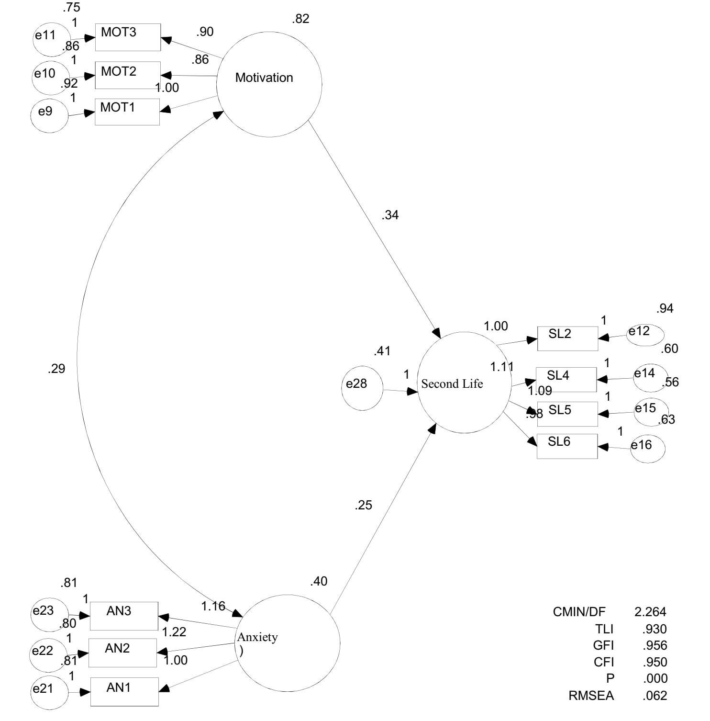

**LIMITATIONS AND RECOMONDATIONS**

The present study was conducted among the undergraduate students at deanship of distance education – Sudan university for science and technology (SUST) in the Sudan in 2015- 2016 academic session, the limitations of the study were: The respondents were only asynchronous learning students, and the study was focused only on face to face course, which was English language course EFL. In addition, this study was tested only two exogenous factors of students anxiety and students motivation, whereas the mediator factor which was perceived satisfaction was excluded because showed poor statistical loading according to fit model. Therefore, the findings might not be generalized to asynchronous learning or face to face interaction courses; for instance English Foreign language course. Further research studies should test in the future why students at (SUST) did not satisfy with second life and did not prefer content interaction via second life environment, and why perceived satisfaction showed very low statistical significant between perceived satisfaction and second life. Instructors at (SUST) should be concerned with positive feedback throughout their delivered courses, and also take into account that variety of learning resources such as online forums to boost students motivation toward English language and lower their anxiety. Also the instructors should invigorate their students during study English foreign language via online learning interactions.

**CONCLUSION**

Motivation and anxiety are widely used in asynchronous learning courses, particularly relevant to student academic achievement and second life environment Motivation and anxiety are. carried out from quantitative research approach. This study tested the relationship between motivation, anxiety and second life environment within asynchronous learning environment. Two exogenous variables were presented: Motivation and anxiety, while endogenous variable second life environment was tested within the original theoretical framework which was adapted from Christopoulos, A (2013) study.

**REFERENCES**

Azhari Abd al-Rahim Ahmed Drewish (2012). *Assurance quality of distance education.* International university of Africa Press.

Aydin, S. (2013). Second life as a foreign language-learning environment. *Turkish Online Journal of Distance Education. (14)*(1), 53-63.

Christopoulos, A (2013). *Higher education in virtual worlds: The use of second life and openism for educational practices.* Master thesis. Unpublished. University of Bedfordshire.

Creswell, J. W. (2010) Educational Research: Planning, Conducting, and Evaluating Quantitative and Qualitative Research. (4th.ed.)

Fornell, C. & Larcker, D. F. (1981). Structural equation models with unobservable variables and measurement error: *Algebra Statistics. Journal of Marketing Research, 18*(3), 382-388.

Gump, A. W. (2015). *Facilitating motivation in a virtual world with a second language acquisition classroom.* PhD thesis unpublished .University of Florida.

Hismaroy, M. (2012). Integrating second life into EFL classroom: Anew dimension in foreign language learning and teaching. *Interactional Journal on anew trends in education and their implications, 3*(4), 100-111.

Hair, J. F. Black, W. C. Babin, B. J, & Anderson. (2010). *Multivariate data analysis.* 7th Ed. New York: Pearson Prentice Hall.

Kline, R. B. (2005). *Principal and practice of structural equation modeling.* (2ed). The Guilford Publication, Inc.

Kruk, M. (2016). Variations in motivation, anxiety and boredom in learning English in second life Retrieved 9th.Nov.2016 from www.polipapers.UPU/index/eruocall/article.

Kamali, T. (2012). *Students' experiences and perceptions of anxiety, motivation and self-confidence in second life during task- based language-learning activities in second language the case study of METU.* Master degree. Unpublished. Middle East Technical University

Milton, J. Jonsen, S. Hirst, S., & Lindenburn, S. (2012). *FL Vocabulary development through activities in an online 3D environment. 40*(1), 99- 112.

Oppeheim, A.N. (1992). *Questionnaire, design, interviewing and attitude management.* (2ed). Martins press Publication.

Peterson , M. (2012). EFL Collaborative interaction in second life. *Journal recall, 24*(1).

Reeve, J. (1997). *Understanding motivation and emotion fort worth.* TX.Harcourt prace college publisher.

Rosenberg, M. J. (2001). *E-learning strategies for delivering knowledge in the digital age*. Published by Mcgraw-Hill.

Sloane, H. N. and Jackson, A. D. (1974). *Guide to motivated learners.* Englewood cliffs, N. J. Educational technology publishers.

Sussman, B. (2007). Teachers, college students lead a second life. USA Today. Retrieved Oct 25, 2015 from http://www.usatoday.com/news/education/2007-08-01-second-life\_N.htm.

Wang, C. X., Hongbo, S., Stone, D. E., & Qiaoquio, Y. (2009). Integrating second life into an EFL program in china : Research collaboration across the continents . *Journal of Tech trends, 53*(6), 1-14 .

Wehner, A. K., Andrew. W., & Dowrey, S. (2011). The effects of second life on the motivation of undergraduate students learning a foreign language. *Journal of computer assisted language, 24*(3), 277- 289.

Wang, C., Song. H., Xia, F., & Yan, Q. (2009). Integrating second life into an EFL program: Students' perspesctives. *Journal of educational technology development and exchange, 2*(1), 1-16.

Wang, C. X., Calandra, B., Hibbard, S. T., & Lefaiver, M. L. (2012). Learning effects of an experimental EFLprogram in second life. Journal of educational technology research and development, 60(5), 143-961.

Yousef, M. S. Jarrah. (2011). *An Investigation of the Effects of Knowledge Conversion Processes on Motivation, Learning Strategies, Meta-cognation, and Performance in a Blended Learning Environment.* PhD thesis unpublished .University Science Malaysia.

1. This study was presented as oral presentation in The International Conference on Modern Education Studies. [↑](#footnote-ref-1)
2. Open University of Sudan [↑](#footnote-ref-2)
3. Open University of Sudan [↑](#footnote-ref-3)
4. Open University of Sudan [↑](#footnote-ref-4)